# **Q1: Create a Dataset Manually**

Create a CSV file named **students.csv** with the following data.

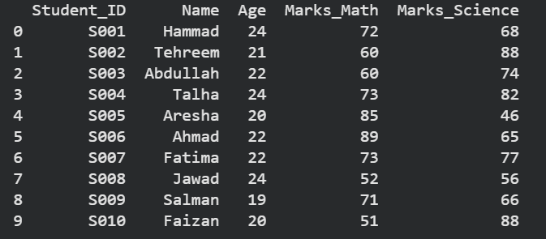

## **Q2: Upload Dataset in Python**

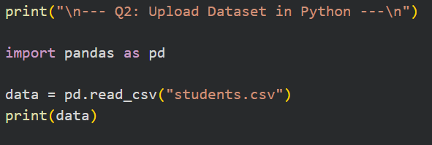

### 

### 

### **✔ Output**



## **Q3: Observe Dataset Information**

### **Dataset Structure**

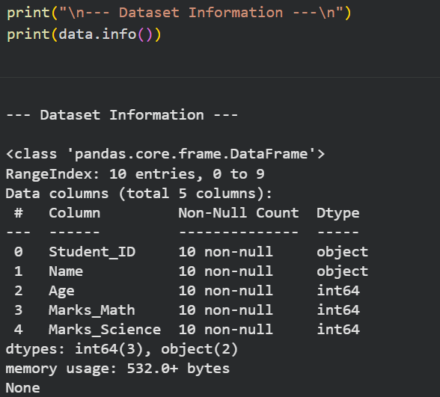

### **Summary Statistics**

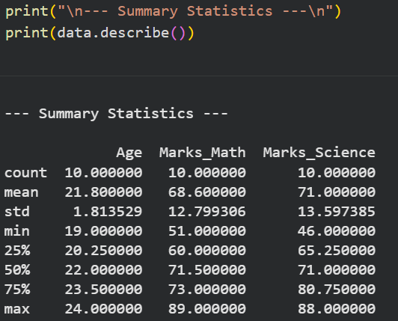

### **Mean of Math Marks**

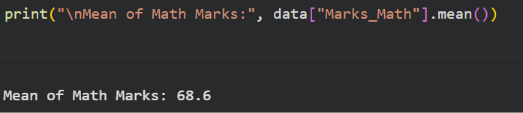

### **Maximum Science Marks**

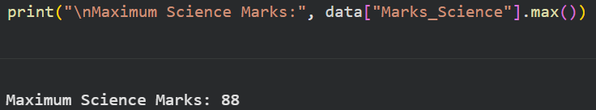

## **Q4: Perform Some Data Analysis**

## **Students with Math Marks > 50**

  
  
**OUTPUT  
**

### **Student with Highest Science Marks**



**OUTPUT  
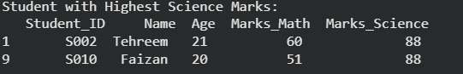**

### **Correlation Between Math & Science Marks**



**OUTPUT  
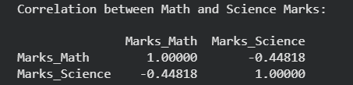**

**Q5: Data Visualization**

  
  
**OUTPUT  
**

### **Bar Chart: Student_ID vs Marks_Math**

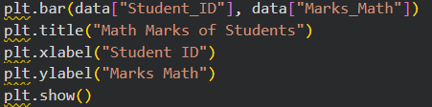  
  
**OUTPUT  
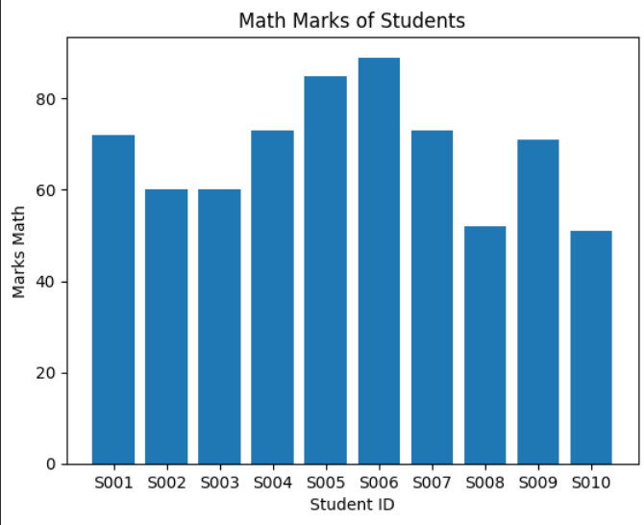**

### **Histogram of Age**

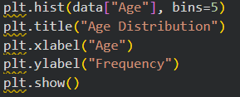

**OUTPUT  
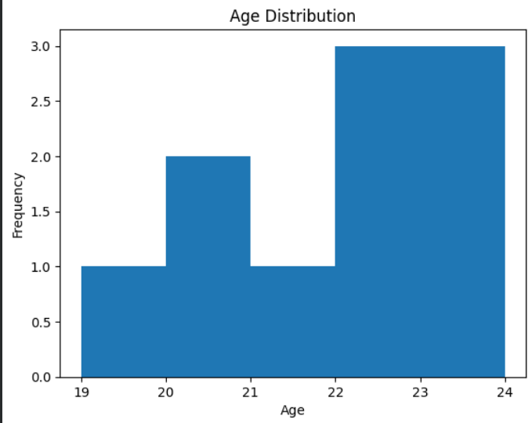**

### 

### 

### 

### 

### 

### **Scatter Plot: Math vs Science Marks**

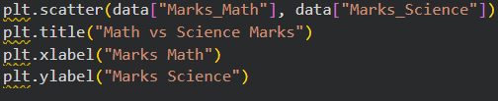  
  
**OUTPUT  
